BIOC 455
Lecture # 17 - Acetylcholine Neurons and Alzheimer’s Disease
Lecturer: Dr. Williams – February 12, 2007

NOTE: This NTC is meant to be used as a study aid to supplement your own class notes. Hence, not all of the text or diagrams contained in the lecture slides will be reproduced here.

Please send any comments or questions about NTCs to either Wanda or James through e-mail at u3.represent@gmail.com .

Before Dr. Williams started, he briefly went over some basics.
Characteristics of acetylcholine (Ach) to keep in mind:
- They are the first neurotransmitter found in brain
- They are produced only in a few thousand neurons, which then project to all areas of brain.
- Most Ach responses are mediated through the ionotropic nicotinic Ach receptors (nAch-receptor) and metabotropic muscarinic Ach Receptors (mAch-receptor).
- Most receptors increase the excitability of post-synaptic neurons. However, presynaptic M2 Ach-receptors inhibit release of neurotransmitters. They do so by closing Ca²⁺ channels and open K⁺ channels in the presynaptic cell, resulting in hyperpolarization that decrease probability of neurotransmitter release.

Lecture slides are the latter part of ‘Class 3 Feb 5th Ach-2007.pdf’
Slide 13 (has a lot of information)
Hypothesis of Ach and Alzheimer’s Disease (AD):
- Cholinergic neurons are first found to be affected.
- How does Ach affect AD? By affecting the prefrontal cortex (decision making) and the hippocampus area (memory).
- Ach is important for memory formation in that cholinergic neurons project from basal forebrain to cortical areas and from septum to memory centre.
- Cholinergic neurons might not have died. However, it’s the synapses that are disturbed in AD. This could occur very early on and not be detected until it is too late.

Ach and AD
- If one blocks NGF (nerve growth factor), cholinergic neurons stay alive but atrophies (shrink) and from senile plaques.

Alzheimer’s Disease:
- AD is the most prevalent progressive neurodegenerative disease.
- AD is associated with aging. The older you get, the more likely you will develop AD. Prevalence rate as follows:
- Age 65 – 74: 3 – 5%
- Age 75 – 84: about 20%
- Age 85 - : about 50%
- There are two categories:
- familial AD
  - accounts for 10% of all AD cases
  - onset typically between 40 to 60 (earlier than normal)
  - certain mutated genes seem critical with AD
- sporadic AD
  - accounts for 90% of all AD cases
  - occurrences are not associated with specific genes, or any Mendelian pattern
  - onset typically after 65
Slide 14 & 15
Timecourse & Diagnosis
- Normal aging → Asymptomatic AD → Subjective cognitive complaints → Mild cognitive impairments (MCI) → dementia (see slide 14/24 for chart)
- Note the difference between MCI and dementia –pervasiveness of symptoms
- What is the point of defining MCI? Such that this can be objectively measured.
- How is AD diagnosed? Patients can be diagnosed clinically (with neuropsychological tests/questionnaires) or with EEG (which measures abnormal electrical patterns).

Slide 16 & 17
Pathology of AD

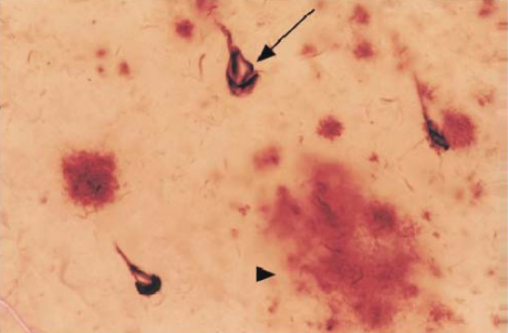
- Two prominent abnormalities in brains of AD patients, which include: Senile plaques (SP, as indicated in solid arrowhead) and neural fibril tangles (NFT, not shown)
- The arrow points to a shrunken pyramidal neuron.
- There are two schools of thought regarding the pathology of AD:
a) SP leads to AD
b) NFT leads to AD

- There is, however, increasing evidence showing that AD results from β-amyloid proteins, which are what constitute SP.
- Where does β-amyloid come from?
a) It comes from APP, or amyloid precursor proteins.
b) APP is a single segment found mostly extracellularly.
c) Three enzymes could cleave it at different sites: α-, β- and γ-secretase.
d) The cleavage action by beta- and gamma-secretase lead to formation of β-amyloid.

Slide 18
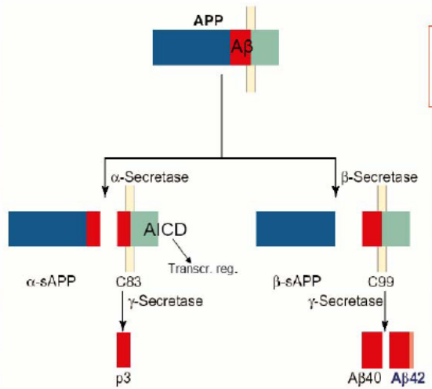
- What goes on in a healthy subject?
- Normally, α-secretase and γ-secretase dominate normal cleavage.
- This produces AICD (APP intracellular domain, possibly a transcription regulator), p3 (non-toxic, role unknown) and alpha-sAPP.

- What goes wrong in an AD patient?
- β-secretase and γ-secretase dominate.
- This results in production of A-β40 and A-β42 (A-β42 is toxic and found in SP)

Slide 19 & 20
- Familial AD research focuses on APP mutations: It is the increased production of A-β42 that results in AD.
- Sporadic AD research found polymorphism of ApoE4:
- This could increase the subject’s chance of getting AD, although this is still unclear.
- The mutation might cause loose binding with Aβ-amyloid, which could increase Aβ-amyloid fibrillation (fibril forms of Aβ-amyloid).

Slide 21
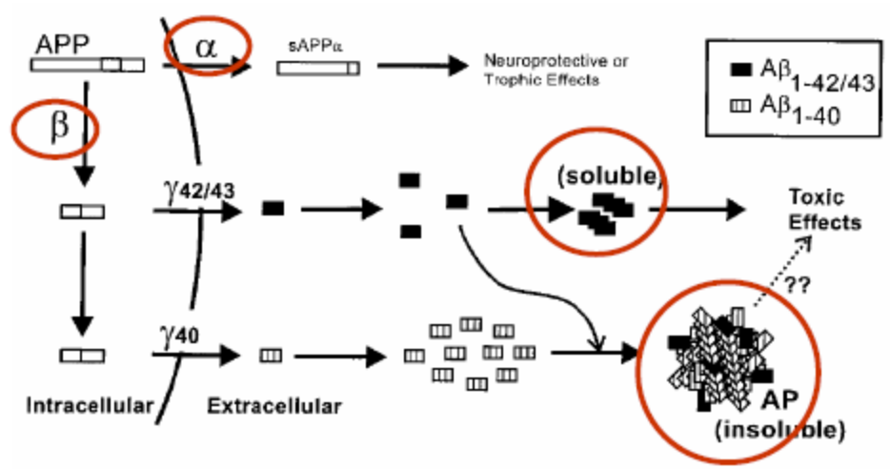
- To recap the normal and abnormal pathways:
- In α-secretase pathway, production of sAPPa is normal
- In β-secretase pathway, production of soluble Aβ occurs; Aβ is small and soluble, but could form SP.
- In β-secretase pathway, production of AP insoluble could also occur directly, leading to SP.

- The soluble form of Aβ might be expressed during MCI (early on before AD develops). Treatment targeting this aspect of Aβ seems promising.

Slide 22 (some info from slide 13 with regard to Donepezil)
Treatment:
- Donepezil is currently the most widely prescribed medication for treating AD.
- It is a cholinesterase inhibitor, which acts to increase Ach at synapse by inhibiting Ach breakdown.
- Its effect on reversing memory loss is very mild, and only works for a subpopulation of patients.
- If one blocks NGF (nerve growth factor), cholinergic neurons stay alive but atrophies(shrink) and from senile plaques.

- There are also two promising possibilities from studying the APP cleavage pathways:
- by inhibiting β – currently at phase II trial, not much side effects
- by inhibiting γ – this enzyme also cleaves Notch, an important molecule during development
Slide 22
Risk Reduction
- Those who have received higher education have reduced prevalence in AD. Perhaps they have more synapses to lose?
- Those who exercise regularly. Perhaps due to growth factors secreted in brain that have a protective effect?
- Arthritis patients who have been on anti-inflammatory agents. This has led to study of Aβ immunization in rats. Rats injected with antibodies against Aβ seem to have decreased size of plaques.
Slide 23
- Why is that? Two possibilities -
- the plaques are attracted to the antibodies through blood brain barrier (BBB)
- the antibodies cross BBB, antibody binding to Aβ leads to degradation of the whole complex by glia cells.

